Thank you for the response, Matt.

Unfortunately I am still having a problem though the bug that you addressed seems to have helped.

So, now when I download Amelia-setup and go to AmeliaView folder within C:\Program Files (x86) I DO have amelia.bat. (see screen shot in attached document).

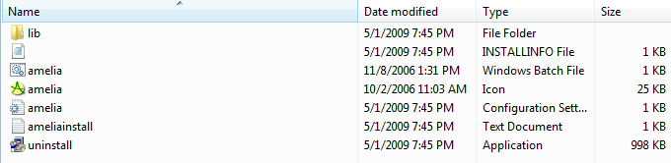

The trouble is when I click on amelia.bat I get error messages (see screen shot in attached document).
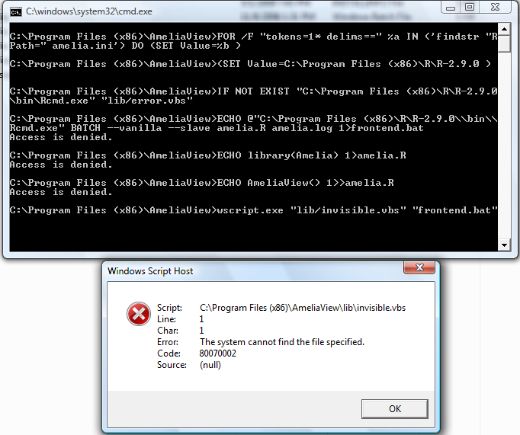Any ideas?

